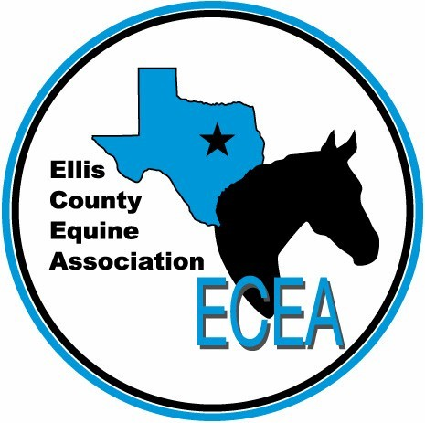

Ellis County Equine Association
Sponsorship Opportunities

- Trailer – 4’ x 4’ $550 (Full for 2019)
- Trailer – 3’ x 3’ $450
- Trailer – 2’ x 2’ $350
- Trailer – 1’ x 1’ $250
- Buckle $150
- Daily High Point $100
- General $50
- Youth Any amount of cash or items

Any sponsorship for ECEA receives the following benefits:
- Mention at all horse shows and other events.
- Facebook promotion.
- Link on ECEA website.
- Mention in ECEA Banquet program, with ability to attend and present awards.
- Trailer sponsors receive a high-visibility, full-color ad on the ECEA trailer.
- Mention in monthly newsletters.
- Ability to display flyers or business cards at registration table for all shows.

Name or business: _________________________________________________________
Phone number: ___________________ Email: __________________________________
Information for Ad: _(or attach flyer or business card)_________________________
__________________________________________________________________________________________________________________________________________________________________________________________________________________________________________________________________________________________________________________________________________________________________________________
Signature: _________________________________________ Date: _________________
Please return by mail to: ECEA, 112 E. Main Street, Italy, TX 76651
Questions? Email ECEA.Board@yahoo.com
Trailer Advertisement Details
All trailer ads will be four-color and appear on the trailer, with the position to be determined at the discretion of the club. Ads will remain on the trailer through December of 2019. We will offer the ability to create designs and artwork if so desired by the sponsor.
Artwork can be provided in any of the following formats: .ai, .eps, .jpg, .pdf (high resolution). A proof will be generated and will be sent for review and approval by both the sponsor and the club Board of Directors.
Once approved, ads will be applied to the trailer for the remainder of the show season and the trailer travels across Ellis County and other local counties in support of the Club, giving the sponsor logo high visibility throughout the year.
Artwork should be emailed to ecea.board@yahoo.com. No artwork? No problem! We can create artwork for you for a small fee. Please contact us for assistance with your artwork.
No advertisements will be placed without receipt of payment.

