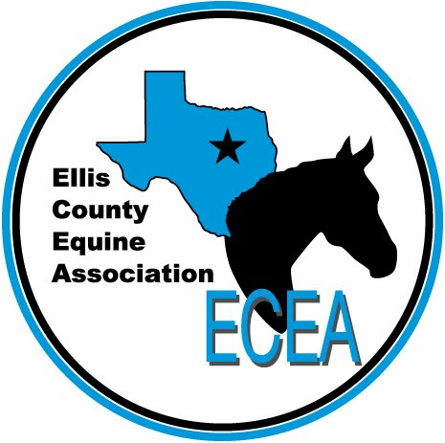
You are invited to the
2016 ECEA Awards Banquet!
Come celebrate the wins of 2016 Horse Show Buckle Series, dine with friends, and receive your awards!
Please RSVP with payment by October 8.

Saturday, October 22, 6 pm
Ellis County Women’s Building
407 West Jefferson St., Waxahachie, Texas

BANQUET RESERVATION FORM
Family Name __________________________________________________
Adult Tickets _________ (X $20) Total adult tickets _________________
Kids’ Tickets (under 18) ____________ (X $15) Total kid tickets __________________
Total Amount Included __________________

Please send to payment and reservation to:
Ellis County Equine Association
112 E. Main St., Italy, TX 76651

